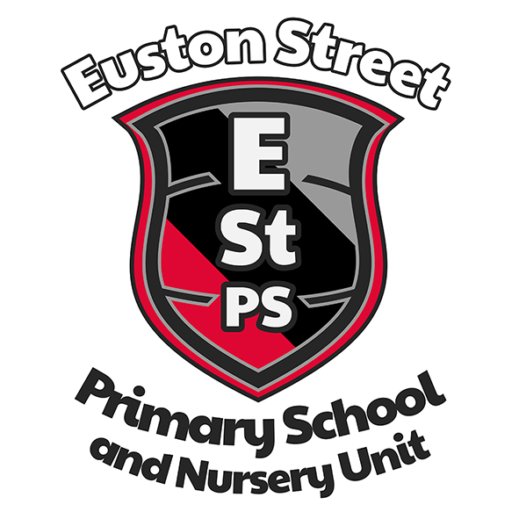

Euston Street P.S.
& Nursery Unit
Uniform Policy
Commitment to keeping policies live!
Date the plan came into effect | September 2023
Who is responsible for this document | Board of Governors, SLT
Issued to | Board, staff, parents
Other related policies | Safeguarding & Child Protection Policy, Pastoral Care Policy, Positive Behaviour and Citizenship Policy
Reviewed | September 2023

EUSTON STREET PRIMARY SCHOOL

Uniform Policy

Introduction

This policy reflects the school mission, vision and values.

Mission
‘Achieving Excellence Together’
‘To work together for excellence in: our learning; our school; our community; and our future’.
Our purpose therefore is to be an excellent school. We continually strive for excellence in every area of school life. To achieve this aim we must always have the right school vision and values and these must be at the heart of all that we do, including our School Development Plan.
Vision
In order to achieve excellence in each aspect of school life, our vision is:
'To create a safe, happy learning community. A community where together, we inspire and equip our pupils so that they fulfil their potential, use their talents and follow their dreams now and always.’
Values
We believe that our school is a place where the child is at the centre.
‘We value kindness, integrity, hard work and mutual respect.'
Good attendance at school is essential for a pupil’s education and establishes a positive working ethos early in life.

Introduction
The purpose of this policy, as with all of our policies, is to support us as we strive for excellence in every area of school life. To achieve this, we must always have the right school vision and values and these must be at the heart of all that we do, including our engagement with parents and guardians.

This policy outlines the roles and responsibilities around school uniform, the school uniform, costs, changes to uniform and additional items of uniform. reasons for the uniform and procedures to support pupils and families with uniform.
This policy operates in tangent with but not only, the Safeguarding and Child Protection Policy, the Pastoral Care Policy and the Positive Behaviour and Citizenship Policy.
This policy has been developed following training by the Education Authority and in consultation with staff, parents and Governors.

This policy aims to:
- Promote equality and value for money and to ensure that no child is discriminated against due to their religion or belief, economic circumstances or social and cultural background.

This policy contains provisions to meet this aim and has been created with health and safety, value for money and practicality at its heart. Additionally, it is important that our pupils feel a sense of belonging to our school. We believe that wearing a smart and practical uniform allows all children, regardless of their backgrounds, to feel equal to their peers and confident in their appearance. We also believe it is important for children to wear clothing that is conducive to a successful learning environment, including activity-appropriate clothing, such as an ESPS PE Kit.
This policy has due regard to all legislation including, but not limited to, the following:
• Education and Inspections Act 2006
• Education Act 2011
• Human Rights Act 1998
• Equality Act 2010
• The General Data Protection Regulation
• Data Protection Act 2018

Roles and Responsibilities
The Board of Governors is responsible for:
• In consultation with the principal and school community, establishing a practical and smart school uniform that accurately reflects the school’s vision and values
• Ensuring that equal opportunities are considered regarding the school’s uniform and that no person is discriminated against.
• Listening to the opinions of parents/carers, pupils and the wider school community regarding changes to the school’s uniform.
• Ensuring that the school’s uniform is accessible and affordable.

The Principal is responsible for:
• Enforcing the school’s uniform on a day-to-day basis
• Ensuring that school staff understand this policy and know what to do if a pupil is in breach of the policy
• Listening to the opinions and wishes of the school community regarding the school’s uniform and making appropriate recommendations to the Governing Board of Governors
• Providing pupils with exemptions as appropriate e.g. for a pupil who has a broken arm and requires a loose-fitting top.

The staff are responsible for:
• Ensuring that pupils dress in accordance with this policy at all times
• Taking appropriate action when pupils are in breach of this policy
• Ensuring that pupils understand why having a consistent and practical school uniform is important e.g. to establish school identity.

Parents/carers are responsible for:
• Providing their children with the correct school uniform as detailed in this policy
• Informing the principal if their child requires a change to their normal unform
• Ensuring that their child’s uniform is clean, presentable and the correct size.

Pupils are responsible for:
• Wearing the correct uniform at all times, unless the principal (Senior Leadership Team) has granted an exemption.
• Looking after their uniform as appropriate
• Respecting why a school uniform is important to the school e.g. to develop a sense of belonging.

ESPS School Uniform (Please see the school Prospectus for more information)
At Euston Street Primary School, the wearing of school uniform is regarded as very important. It helps create a sense of community among the pupils and encourages them to take a pride in their appearance.
It is school policy that all children are expected to wear school uniform every day as follows:
GIRLS
l Grey pinafore/skirt*
l White Shirt and school tie
l Grey cardigan/grey V-neck jumper
l Black shoes
l Grey tights/White socks
l Red checked dress (summer only)
BOYS
l Grey trousers
l Grey/White shirt and school tie
l Grey school V-neck jumper
l Black shoes
l Grey socks
*Girls may wear grey school trousers instead of skirts/pinafores during the winter term or extreme cold weather but please note that for special occasions such as choir visits, school assemblies, etc. pinafore/skirt should be worn.
Ties School ties are available from the school office – cost £2.50. Nursery Red Sweatshirts are available to purchase from Nursery Staff.
Individual needs and or requirements relating to uniform will be dealt with on a case by case basis – please see below.

Cost and Availability
ESPS ensures that the School Uniform Policy does not discourage parents/carers from applying for a place for their child. The school is committed to meeting recommendations on costs and value for money and parents are regularly informed of uniform grants provided by the Education Authority (https://www.eani.org.uk/financial-help/free-school-meals-uniform-grants) Every care is taken to ensure that our uniforms are affordable for all current and prospective pupils, and that the best value for money is secured through reputable suppliers. The Board of Governors have agreed to not require a badge on the school jumper to help make the main uniform affordable for the majority of parents and to ensure that it is always readily available at most larger supermarket chains or clothing stores.
The school does not amend uniform requirements regularly and will always request the views of parents/carers and pupils when considering any changes to school uniforms.

Labelling uniform
All items of clothing and footwear must be labelled with the pupil’s name

Religious Clothing/ PDMU
Some religions and beliefs require their members to conform to a specific dress code. The school does not discriminate against any religion or belief; however, the school weighs the needs and rights of individual pupils against the health and safety concerns of the entire school community. ESPS endeavours to allow religious requirements to be met, wherever possible.
Parents should make an appointment with the school principal if any other specific adjustments to uniform are required. Parents’/carers’ concerns and requests regarding religious or issues relating to PDMU and school uniform are dealt with on a case by case basis by the principal and the Board of Governors. The school endeavours to ensure that our uniform is potentially gender neutral and as inclusive as possible.

Nursery
The red Nursery jumpers are available from the school office.

SEN
Pupils who have specific learning needs can, at times for a variety of reasons, require adjustment to uniform. Any SEBW or SEN sensory issues requiring uniform adjustment will be dealt with on a case by case basis with the school Learning Support Coordinator, Senior Leadership Team and the school principal.

Ties
Ties can be purchased at the school office. Both elasticated and non-elasticated versions are available. Prices are normally £2.50 but this may vary depending on supplier’s costs.

Book Bags
ESPS Book Bags can be purchased at the school office. Prices are normally £5 but this may vary depending on supplier’s costs.

PE Kit
ESPS PE Kit can be purchased from Signature Works Unit 5b, Castlereagh Business Park, 478 Castlereagh Rd, Belfast BT5 6BQ.
Prices are normally £3 for a T-shirt and £15.50 for a hoodie but these may vary depending on supplier’s costs.

Educational Visits (including swimming)

Full school uniform will be required for most Educational Visits unless a form of activity requires that the school PE Kit may be worn. Pupils are permitted to wear their PE kit for swimming days in Years 5 - 7.

PE Days
Pupils are expected to wear their PE to and from school on the days of their PE lessons. They will wear full school uniform on other days. Parents/carers are responsible for ensuring their child is dressed appropriately for PE. Pupils wearing alternative PE clothing to the school PE Kit, may not be permitted to participate in PE lessons if their attire is considered unsuitable or unsafe.
Failure to comply may result in a meeting being organised with the parents concerned.

Hair & Jewellery
Hair should be kept neat and tidy and long hair should be tied back especially during PE. Appropriate cuts and natural colours of hair are required. Pictures or words shaved into hairstyles are not acceptable during term time.
In the interests of safety, jewellery should not be worn to school. The only exceptions are small ear studs, for those who have pierced ears and a watch. Children wearing other earrings, piercings or jewellery will be asked to remove them during school.
All jewellery must be removed during practical lessons, for example, PE lessons / swimming lessons. If children cannot remove their own earrings, then this should be done at home on the day of PE. The school is not responsible for the cost of lost piercings and jewellry worn to school. Failure to comply may result in a meeting being organised with the parents concerned.

School Bag
Whilst school bags are not compulsory, it is a useful item for most children in order to carry their lunch and snack, books and other items needed for school.

Coats
Whilst a coat is not compulsory, it is sensible to have one for wet and colder days.

Water Bottle
All children are encouraged to bring a water bottle to school each day to drink and stay hydrated as part of the school healthy lifestyle policy.

Adverse Weather
During hotter weather, pupils may wear a cap to and from school and during playtime. During cold weather pupils are permitted to wear boots to and from school and change into school shoes once in school.

Lost items
Whilst the school is not responsible for items of uniform that are lost, it will endeavour to retain all items found for a period of up to 1 year.
Parents will be invited to school at least once a year to try and claim any lost items. Parents should contact school as soon as they become aware of a lost item.

What happens when uniform is not worn
Aside from agreed specific circumstances as outlined in this policy document, other individual family circumstances will be considered in the event that a child is not wearing the correct uniform.
Failure to comply with the uniform policy may result in a meeting being organised with the parents concerned. If parents continue to fail to comply with school uniform requirements, it may result in sanctions being applied to the pupil concerned as outlined in the Positive Behaviour and Citizenship Policy.

Complaints and Challenges
The school endeavours to resolve all uniform complaints and challenges locally and informally, in accordance with the school’s Complaints Policy. To make a complaint, parents/carers should refer to the Complaints Policy and follow as outlined.

